## Language Pack Test UI Automation

Windows 7 Ultimate/Enterprise

Language Pack Test UI Automation allows user to install any combination of specified language packs. Prior to each installation, the automation checks if the offered language packs are valid. It will then install the language pack and verify all UI’s and registry keys. After running the test on Windows 7 Ultimate/Enterprise, user can be confident that the offered language packs, UI’s, registry keys, and the language packs have been installed and displayed correctly.

Windows 7 non-Ultimate/Enterprise

For any SKU’s that are not Ultimate/Enterprise, the test will simply verify that no single-language language packs are offered.

## Process of the Test

For Windows 7 Ultimate/Enterprise, the automation verifies:

* Offering Logic:
  + Base language is NOT offered
  + Installed LPs are NOT offered
  + ALL other LPs that have not been installed and are not the base language are offered
* WU UI:
  + WU shows installation progress, completion, and cancelation windows
* Only the registry keys of installed LPs and base language are stored
* Cancelation of the language pack installation:
  + Canceled LP will not be installed
  + Canceled LP will be offered again
  + Cancelation UI’s are displayed properly
  + Registry key for canceled LP will not be stored

### The arguments to be passed to the automation are as follows:

L_KBNumber : KB of the Language Packs (All language packs have the same KB)

L_CancelFirstLP : If **“true”** the first language will be canceled then reinstalled to verify cancelation. If cancelation is not interested, set it to **“false”**.

L_LangPacks : A list of all language packs to be installed.

Windows 7 Ultimate/Enterprise

[L_KBNumber] InstallWin7LP [L_CancelFirstLP] [L_LangPacks]

(example: KB123456 InstallWin7LP true ar-SA bg-BG cs-CZ da-DK)

Windows 7 NON-Ultimate/Enterprise

[L_KBNumber] InstallNoneWin7LP

(example: KB123456 InstallNoneWin7LP)

**The following diagram shows the flow of the process for Windows 7 Ultimate/Enterprise.**

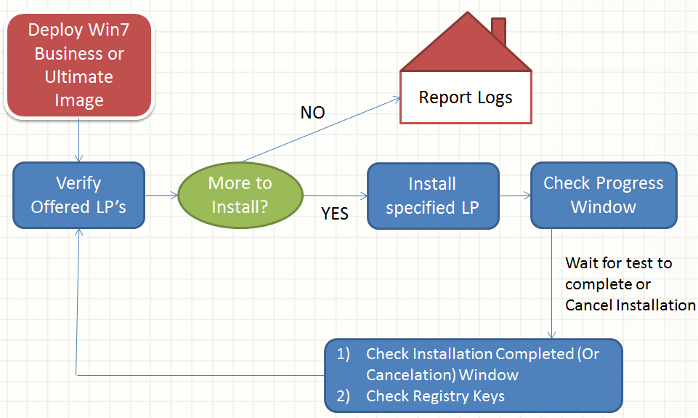

**The following diagram shows the flow of the process for Windows 7 NON-Ultimate/Enterprise SKU’s.**

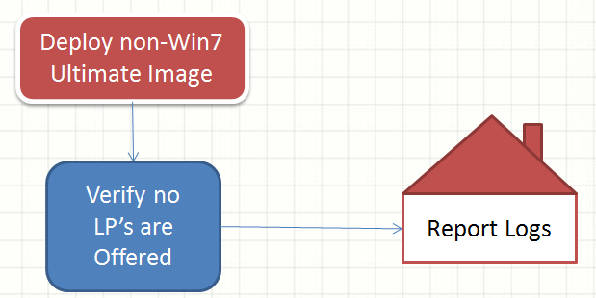

## Design Assumptions and Dependencies

* ?????